News from Peter

Hello Lakeview friends and family in the USA,
It’s been quite a while since we connected and I know that many of you were wondering if we’d disappeared off the face of the earth! Put it down to COVID (the new excuse ;-)), the blistering summer in India and a whole new world of uncertainty that we – and most of you – are facing. But through it all, we affirm that God has been faithful and has more than provided for our every need.
This newsletter features our Graduation 2022 and the new programs that are due to commence in the coming academic year. In spite of various setbacks, our Lakeview team is energized and geared up to face the future with confidence. Things may not look like before, but we believe that they will all be GOOD – simply because God is in all of them!
On a personal note, Cathy got another clear OK from the doctor last Monday, and she is back to carrying 95% of her earlier load of teaching and ministry. Thank God with us for His everlasting love, grace and peace.
We request you to pray for us as we find new and fresh ways to serve God in India (and beyond) in this new post-COVID world. We will keep you updated on Lakeview’s new avatar in the coming months.
Anticipating great new workings of our partnership with God and you,
Peter, Cathy and the India Lakeview team.

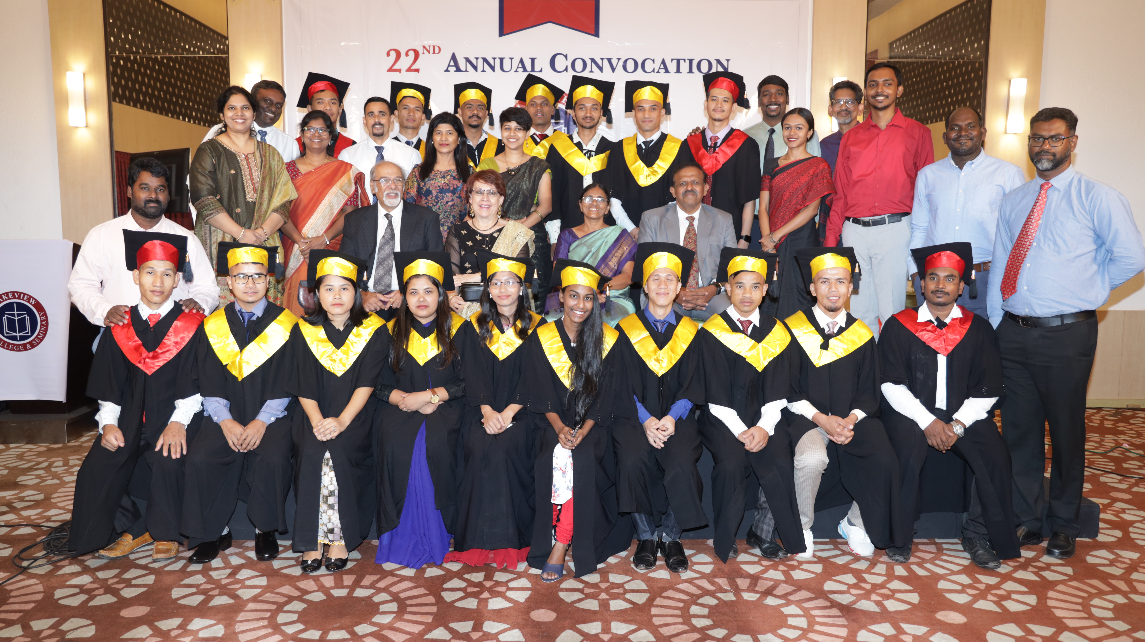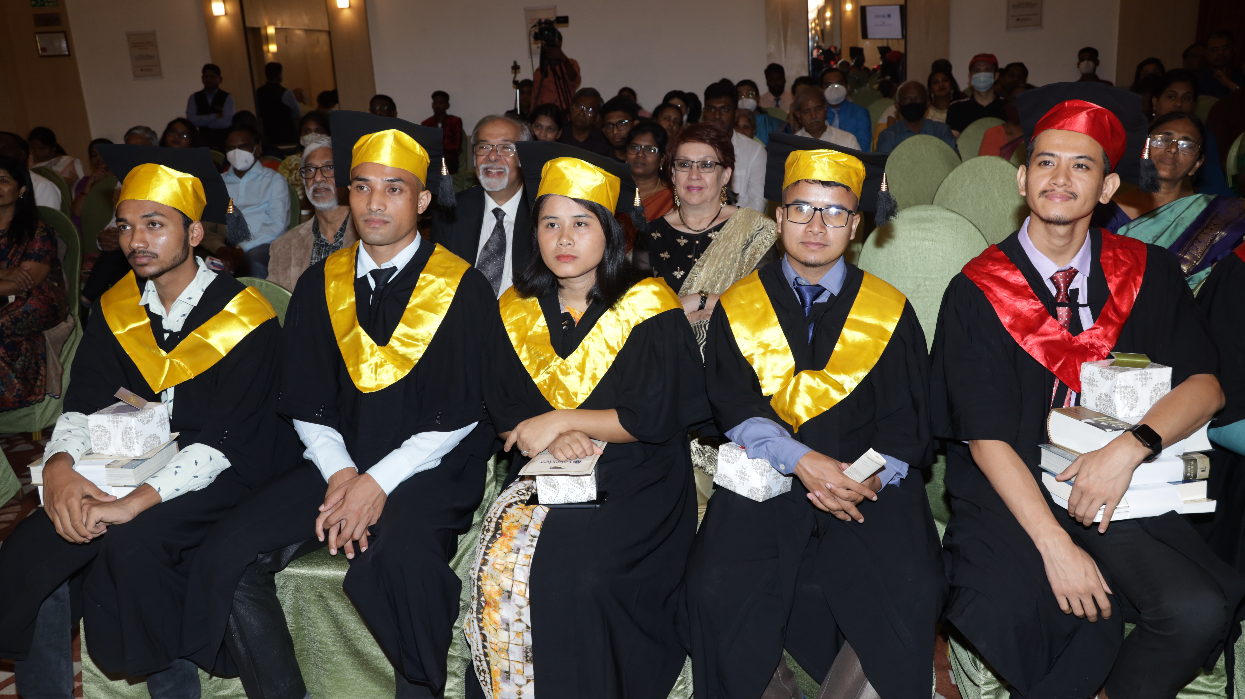

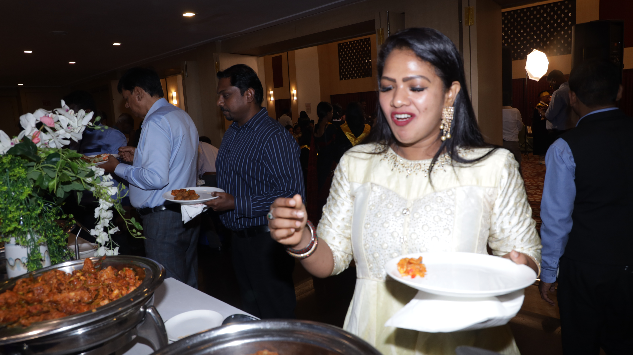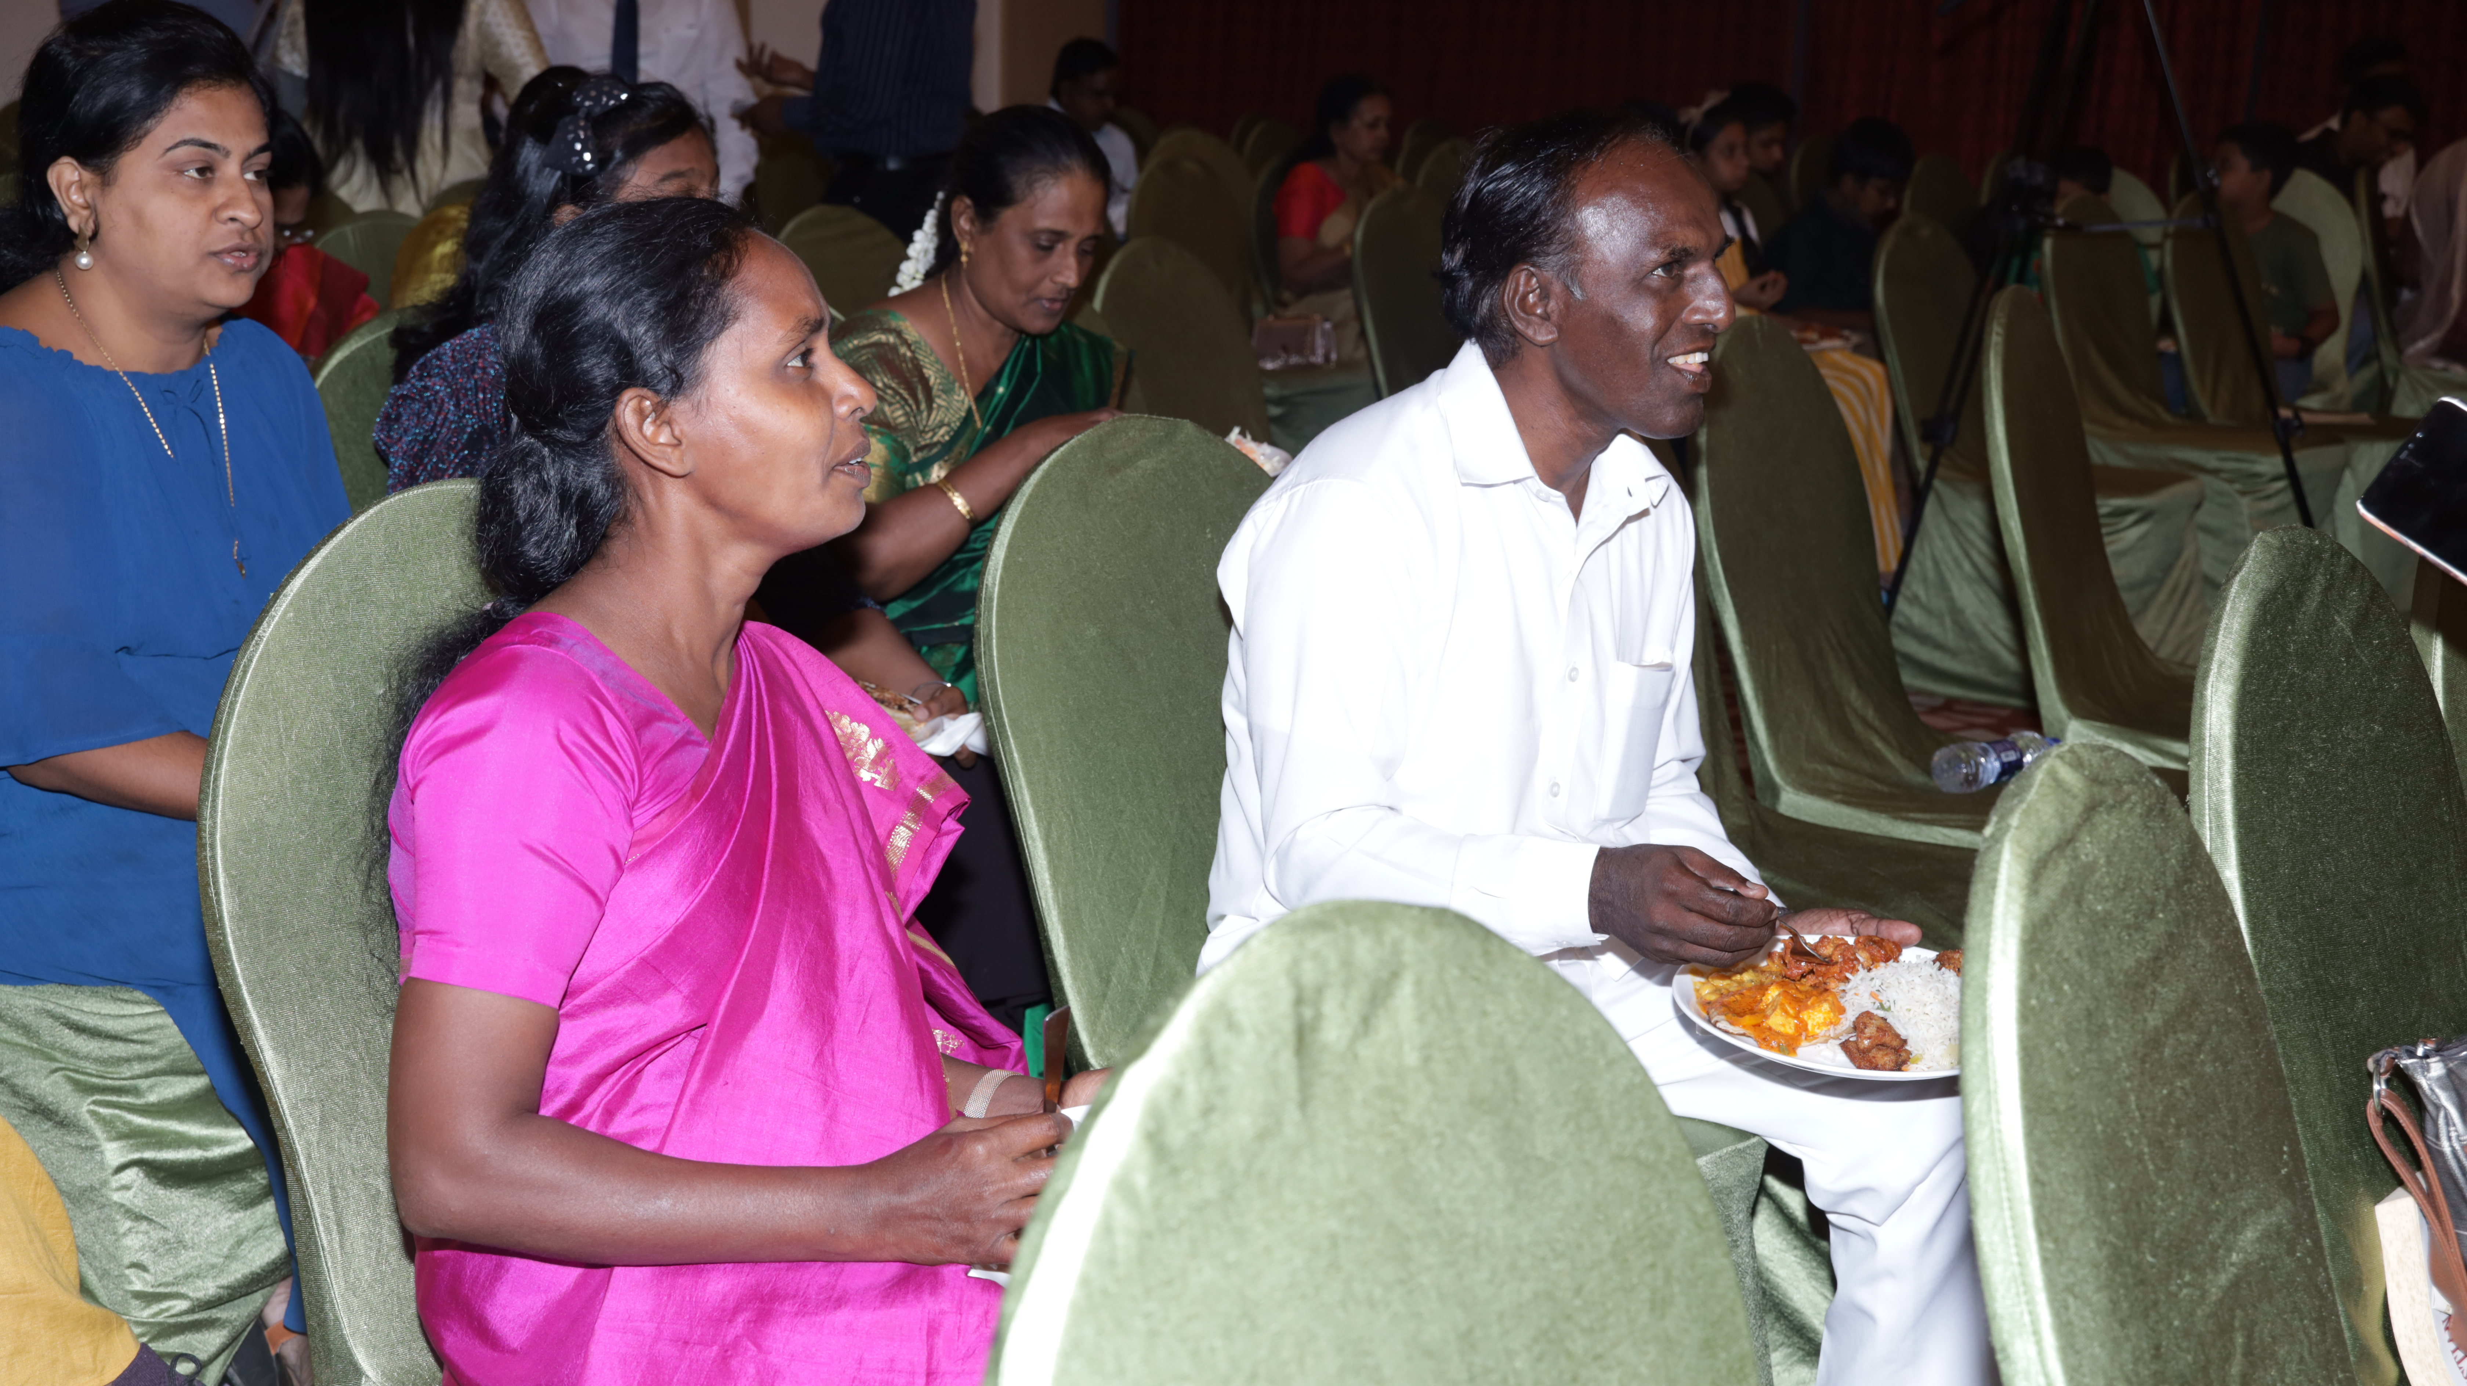

New Plans

As we navigate through this pandemic, and the religious and political atmosphere in India, Lakeview has decided to modify our training pattern to become more relevant to the needs of people of India.
Our new curricula is a good blend of Theology and Ministry to develop skills required for serving the people of India in their own context. We have also adapted our practical focus so that the serving opportunities are not limited to the four walls of the church.
The specializations we offer facilitate students to choose an area of interest, so they can be thoroughly equipped in a particular field. Students who are interested to serve in the Church can specialize in Christian Studies. The other major specializations we offer at both Bachelor and Master levels are Christian Counseling, Media Communications, and Business Entrepreneurship.
Furthermore, inquiries reveal that a lot more people are interested in online specialization programs in Counseling and Christian studies. Beginning July 2022, we offer a Certificate in Christian Counseling for six months and are continuing the six-month certificate in Christian Studies.
We thank you for your support and prayers that has made it a lot easier for us to step up and face the future. Please continue to pray for us.

Solomon Yesudas

New Construction and Renovation

We have given a new coat of paint to our main building, Berea Hall, the girl's dorm and the cafeteria too. We have also created a new entrance to the library, constructed a new security room, and extended our cook's room to create more living space for him and his family. We have also done some repairs in the dormitory of the girls and boys as well. Work on our overhead tank is in progress. We couldn't have done all of this without your help. Thank you for your support.
Rex Leonard

